**AKG_3138_Z_00070_D5_Handheld_Supercardioid_Dynamic_492702**

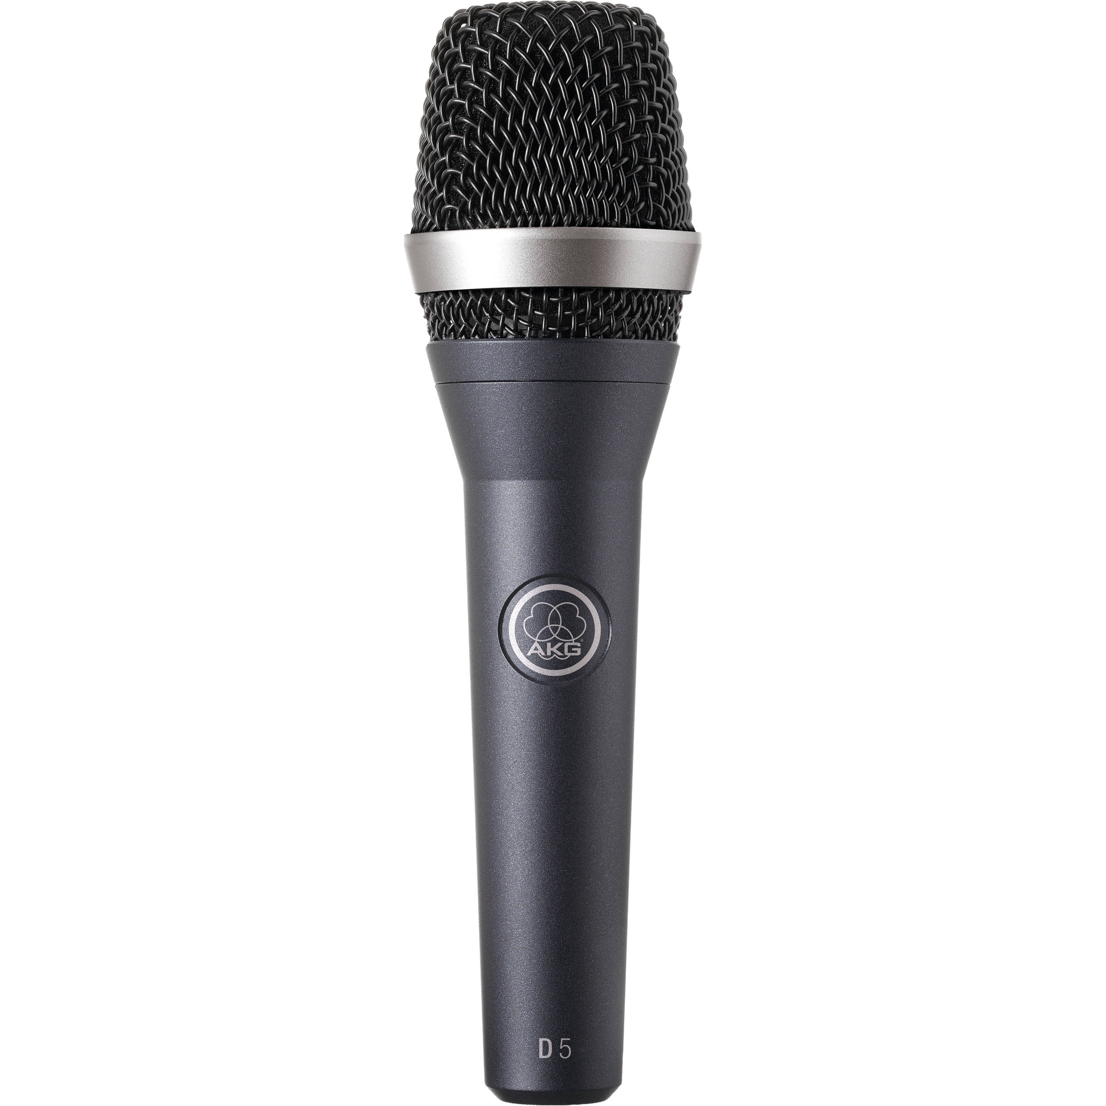

**Specifications:**

|  |  |  |  |  |  |  |  |  |  |  |  |  |  |  |  |  |  |  |  |  |  |  |  |  |  |  |
| --- | --- | --- | --- | --- | --- | --- | --- | --- | --- | --- | --- | --- | --- | --- | --- | --- | --- | --- | --- | --- | --- | --- | --- | --- | --- | --- |
| |  |  | | --- | --- | | Transducer | Dynamic | | Polar Pattern | Supercardioid | | Frequency Response | 70Hz to 20kHz | | Dynamic Range (Typical) | *Not Specified By Manufacturer* | | Signal-to-Noise Ratio | 76 dB | | Maximum Input Sound Level | 147/156 dB SPL (for 1% / 3% THD) | | Power Requirements | No | | Output Impedance | < / = 600 ohms | | Output Connectors | 3-pin XLR | | Pad | No | | Low Frequency Roll-Off | No | | Dimensions (LxDiameter) | 2 x 7.3" (51 x 185.2mm) | | Weight | 340g (12 oz) | |

**Electro-Voice 635A Interview Mic (Beige)**

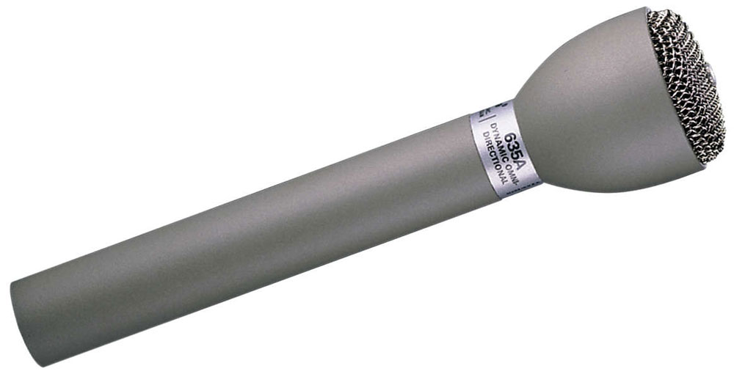

**Specifications:**

|  |  |
| --- | --- |
| Polar Pattern | Omnidirectional |
| Element Type | Dynamic |
| Output Connector | 3-Pin XLR Male |
| Frequency Response | 80 Hz - 13 kHz |
| Output Impedance | 150 Ohms |
| Sensitivity | 1.4 mV/Pa |
| Power Requirements | *None* |
| Case Material | Steel |
| Dimensions (L x D) | 5.9 x 1.4" / 149.9 x 35.6 mm |
| Weight | 6 oz / 170 g |

**Shure Beta 57A Instrument Microphone**

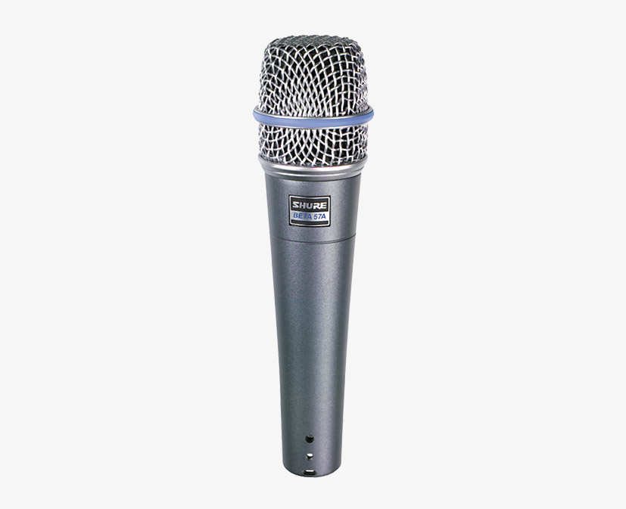

**Specifications**:

|  |  |
| --- | --- |
| Transducer | (Moving Coil, with Neodymium Magnet) Dynamic |
| Polar Pattern | Supercardioid |
| Frequency Response | 50 Hz - 16 kHz |
| Maximum Input Sound Level | *Not Specified by Manufacturer* |
| Power Requirements | None *Dynamic, Requires No Phantom or Battery Power* |
| Output Impedance | 150 Ohms (290 Ohms Actual) |
| Output Connectors | XLR-3M Type |
| Applications | Drums, Guitar Amplifiers, Brass, Woodwinds and Vocals. |
| Dimensions | 6.19 x 1.75" (157 x 32mm) LxDiameter |
| Weight | 9.71 oz (272g) |

**Shure KSM8 Handheld Vocal Microphone (Black)**

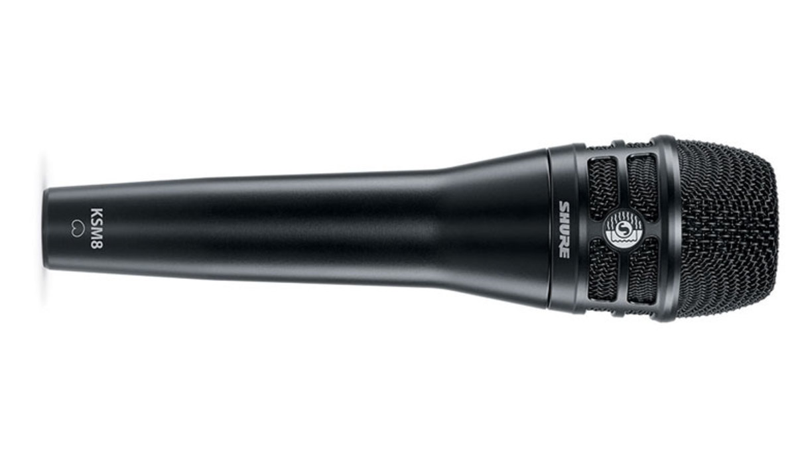

**Specifications:**

|  |  |
| --- | --- |
| Cartridge Type | Dual-Diaphragm dynamic (moving coil) |
| Frequency Response | 40 Hz to 16 kHz |
| Polar Pattern | Cardioid |
| Output Impedance | 300 ohms |
| Sensitivity | -51.5 dBV/Pa (1.85 mV) at 1 kHz, open circuit voltage |
| Polarity | Positive pressure on diaphragm produces positive voltage on pin-2 with respect to pin-3 |
| Connector | 3-pin XLR male |
| Housing | Die-cast aluminum with paint or brushed nickel finish |
| Dimensions | Not specified by manufacturer |
| Net Weight | 11.6 oz (330 g) |

**Shure SM58S Vocal Microphone with Switch**

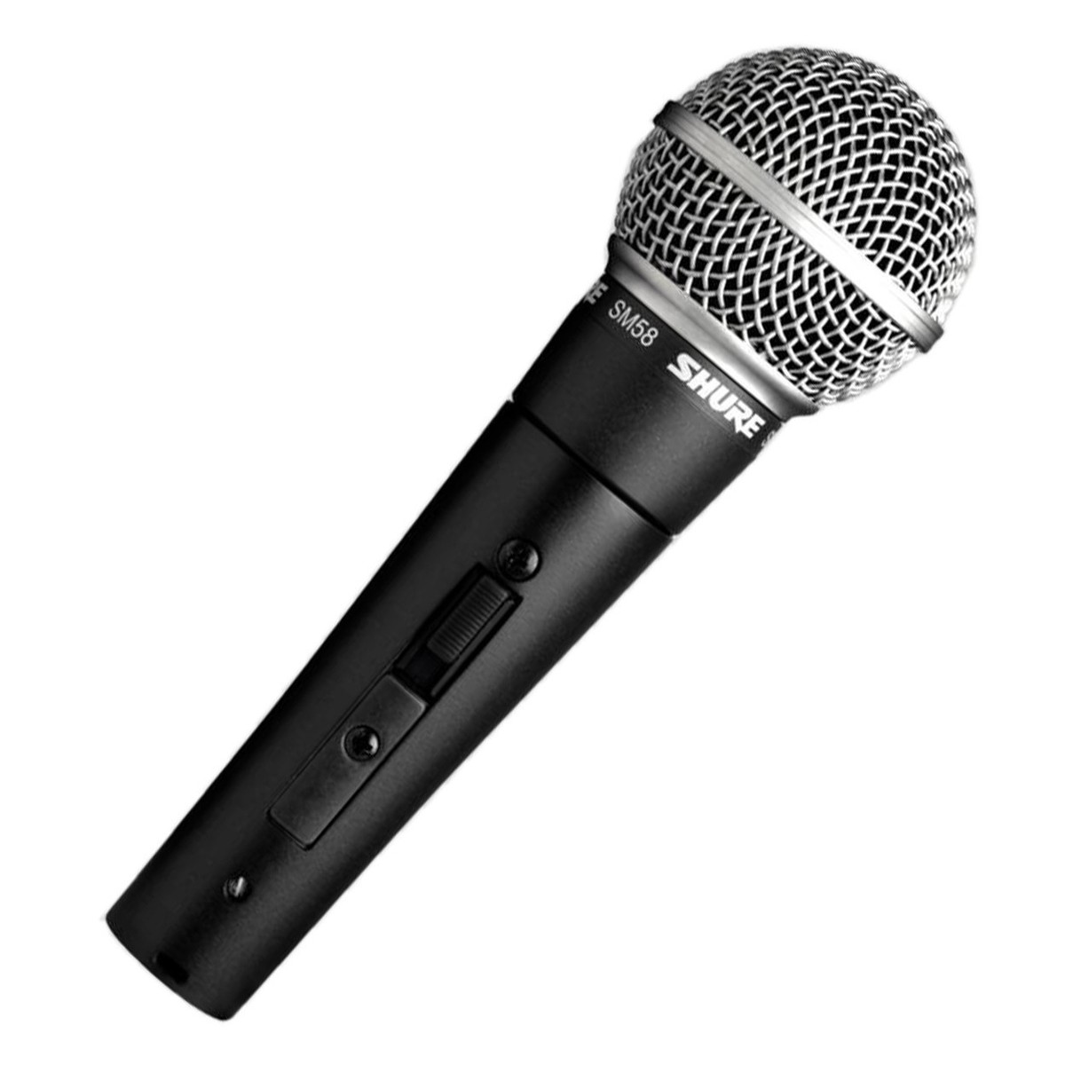

**Specifications:**

|  |  |
| --- | --- |
| Sound Field | Mono |
| Transducer | Dynamic |
| Polar Pattern | Cardioid |
| Frequency Range | 50 Hz to 15 kHz |
| Impedance | 150 Ohms |
| Sensitivity | -57.5 dBV/Pa at 1 kHz |
| Output Connectors | 1 x 3-Pin XLR |
| Operating Voltage | Not Specified by Manufacturer |
| Length | 6.38" / 162 mm |
| Diameter | 2.01" / 51 mm |
| Weight | 0.82 lb / 372 g |

**Shure_VP64A_VP64A_Omni_Dynamic_157395**

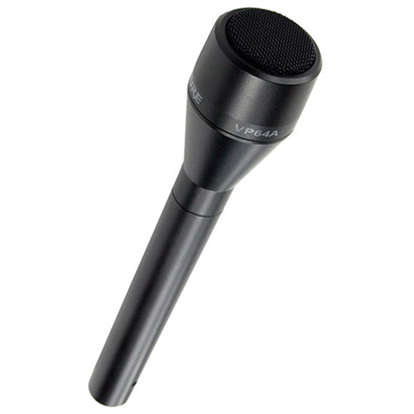

**Specifications:**

|  |  |
| --- | --- |
| Polar Pattern | Omnidirectional |
| Element Type | Dynamic |
| Output Connector | 3-Pin XLR Male |
| Frequency Response | 50 Hz - 12 kHz |
| Output Impedance | 300 Ohms |
| Power Requirements | *None* |
| Dimensions (L x D) | 7.9 x 1.5" / 200.7 x 38.1 mm |
| Weight | 5.6 oz / 158 g |